DC/DC Converter Start Up Simulation

11

10

9

8

7

6

5

4

3

2

1

1

2

3

4

5

6

7

8

9

10

Summary

Outline

*Headings you add to the document will appear here.*

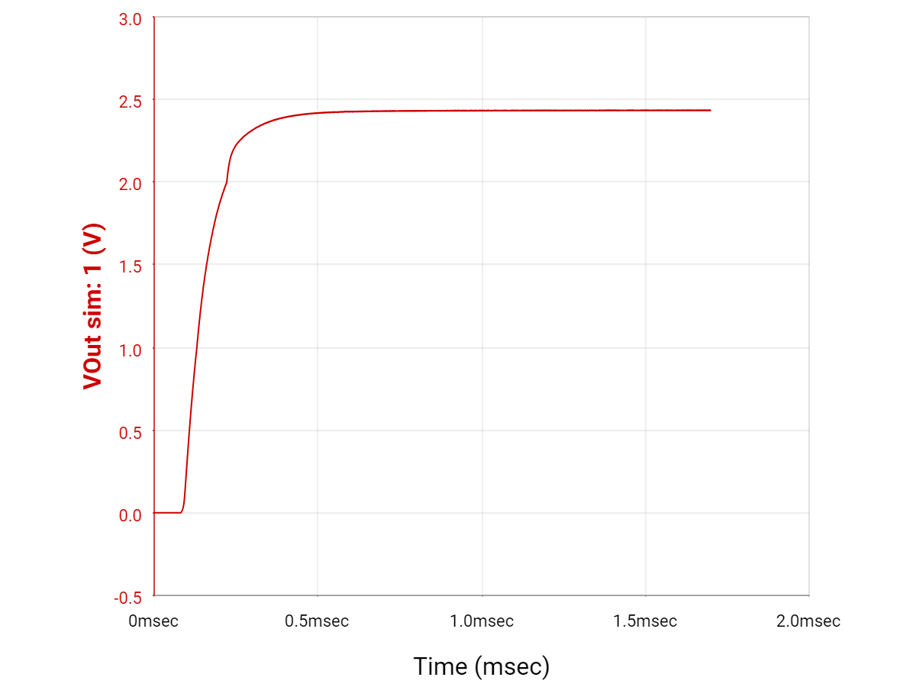

Start Up Time: 1.63 ms

Voltage Regulator Used for Circuit: <https://www.ti.com/lit/ds/symlink/tps63070.pdf?ts=1696026763362&ref_url=https%253A%252F%252Fwww.ti.com%252Fproduct%252FTPS63070>

Battery Charger Used for Starting Design:

<https://www.ti.com/lit/ds/symlink/bq24171.pdf?ts=1696103869846&ref_url=https%253A%252F%252Fwww.ti.com%252Fpower-management%252Fbattery-management%252Fcharger-ics%252Fproducts.html>

DC Jack Used in Design:

<https://www.cuidevices.com/product/resource/pj-002bh-smt-tr.pdf>

Fuel Gauge:

<https://www.ti.com/lit/ds/symlink/bq28z620.pdf?ts=1697497739906&ref_url=https%253A%252F%252Fwww.ti.com%252Fproduct%252FBQ28Z620>

Battery:

<https://www.digikey.com/en/products/detail/jauch-quartz/LI18650JP2S2P-PCM-2-WIRES-70MM/9562752>

Possible New Battery Charger -

<https://www.ti.com/lit/ds/symlink/bq25306.pdf?ts=1706547609677&ref_url=https%253A%252F%252Fwww.ti.com%252Fproduct%252FBQ25306>

Fuel Gauge Technical Reference Manual - <https://www.ti.com/lit/ug/sluuco9a/sluuco9a.pdf?ts=1709417492458>